Guide for trainers

MELODY

“A harmonised CBRN training curriculum for first responders and first receivers”

# Acknowledgements

The material for this curriculum was developed and reviewed by the MELODY consortium, existing of Rijksinstituut voor Volksgezondheid en Milieu (RIVM), Nederlandse Organisatie voor Toegepast Natuurwetenschappelijk Onderzoek (TNO), Studiecentrum voor Kernenergie / Centre d’etude de l’Energy (SCK•CEN), Universita degli studi di Roma tor Vergata (UNITOV), European CBRNE Centre (Umeå University), Uniwersytet Lodzki (ULOD), ISEM-Institut pre Medzinarodnu Bezpecnost a Krizove Riadenie (ISEMI) and evaluated by organising test events at Keszenleti Rendorseg (HNP-BDU), Lansi-Suomen Pelastusharjoitusaluesaatio SR (ESTC-WF), Autonoom Provinciebedrijf Campus Vesta (Vesta) and Defence CBRN Centre (DCBRNC). External reviews have been performed by subject matter experts affiliated in the EU Horizon2020 project NO FEAR, Nationaal Vergiftigingen Informatie Centrum (NVIC), Cameron Mann, CBRN expert, and Dr. Nick Gent, Senior Medical Adviser.

Project MELODY “A harmonised CBRN training curriculum for first responders and medical staff” is co-funded by the European Commission under grant nr 81480 within the ISFP-2017-AG-PROTECT programme.

Contents

Acknowledgements 2

1. Introduction 5

2. Intentions, aims and content of the curriculum 7

2.1 The modular approach 7

2.2 Target Audience 8

2.3 The trainer’s experience and expertise 8

2.3.1 Trainer specification 8

2.4 Language 9

3. The MELODY curriculum 10

3.1 Modules 10

3.2 Learning objectives 12

4. MELODY training material and training methods 14

4.1 Theoretical training 14

4.1.1 Classroom presentations 14

4.1.2 E-learning 15

4.1.3 Test questions 15

4.2 Practical training 15

4.2.1 Scenario discussions 15

4.2.2 Table top exercises 16

4.2.3 Hands-on training 16

4.3 The MELODY MIND card game 16

5. How to use the curriculum and compose a MELODY training 17

5.1 Guidance on how to compile a training course tailored to the trainees needs 17

6. Tips & Tricks 19

Annex 1: Background 20

Annex 2: The MELODY CBRN training curriculum (detailed) 21

Annex 3: Classroom presentations 24

Material 24

Notes for trainer 24

Flag or question mark 25

Test component 26

Annex 4: Interagency Collaboration Exercise 27

Aim of the exercise 27

Personnel 27

Materials 27

Workflow 27

Annex 5: Scenario discussions 30

How to select and prepare a scenario discussion 31

Annex 6: Tabletop exercise (TTX) 35

What is a TTX? 35

Exercise materials 38

Personnel: 39

1. Trainer 39

2. Support trainers 41

3. Expert-Observers 41

Annex 7: Examples of composing a training 42

Case 1: CBRN basics course for medical professions (4 hours) 42

Case 2: CBRN refresher course for dispatch officers, police and ambulance personnel (1 day) 44

# Introduction

Previous incidents involving CBRN agents, such as the two incidents in 2018 with a Novichok nerve agent and the highly toxic substance ricin, have demonstrated the relevance of those in the first line of action (first responders and first receivers) being aware and recognizing a CBRN incident, as well as being prepared on how to act safely. A CBRN incident can be caused by accident or negligence, but also by deliberate release of CBRN agents or in rare cases a terrorist attack. As identified in the MELODY project, the EU first responder community has specific CBRN training needs. The MELODY curriculum targets these specific training needs in order to improve CBRN awareness amongst first responders or first receivers, to understand which personal protection measures to apply and to know which specialist (teams) to call. These goals of the MELODY training curriculum should always be in the back of the trainer’s mind when implementing MELODY, as it is easy to lose sight of this when focusing on the details of the modules in the curriculum and the separate presentation.

This guide for trainers serves as a handbook for the MELODY CBRN training curriculum. It explains the background and aim of the MELODY training, gives information about the curriculum and its modules, the different training methods for the MELODY training material and presents the learning goals for the different modules. The guide further provides instructions for the trainer on how to tailor the training to the target audience.

The guide includes the following parts and should be read in its entirety to give the trainer the full picture about the MELODY curriculum and its intended use.

1. **Intentions, aims and content of the curriculum:** Gives information about the scope of MELODY, the modular approach, for whom the MELODY training is intended, the experiences and expertise that is required for a trainer and the language in which the training material is delivered.
2. **The MELODY curriculum:** Gives an overview of the different modules and the specific learning objectives.
3. **MELODY training material and training methods:** Gives an explanation of the applied training methods, the developed training materials as well as an overview of the training methods per module in relation to the various learning objectives.
4. **How to use the curriculum and compose a MELODY training:** In this part the different training methods and training material are presented. Guidance as on how to use the material and how to deliver MELODY training is provided.
5. **Tips & tricks:** Provides the trainer with some general tips and tricks when preparing a training.

**Annex 1-7:** Annex 1-7 contain additional and more detailed information about the MELODY curriculum and how to use the material for tailored training.

* **Annex 1** refers to more background information on project MELODY and the MELODY CBRN training curriculum.
* **Annex 2** lists the MELODY curriculum, including the 7 modules, their learning objectives and the training material presentations that need to be trained to be able to achieve the learning objectives.
* **Annex 3** explains how material for classroom lectures should be used by the trainer. Every slide of a PowerPoint presentation includes instructions in the slide notes guiding the trainer through the slides. It also explains how to use the test component.
* **Annex 4** describes an interactive exercise in classroom presentation 7.1. It describes to the trainer how to introduce first responders from one organization to the tasks and activities of another first responder organization in an interactive setting. This to better understand the other first responder organisations, its capabilities and possible limitations.
* **Annex 5** describes the scenario discussions, how they are composed and how the training material should be used. It also gives the trainer information on how to lead a scenario discussion and how to interact with the trainees.
* **Annex 6** describes to the trainer how a table top exercise should be conducted, explaining the trainer’s role as well as other roles that are required, such as expert observer and evaluator.
* **Annex 7** contains examples of how to compose different trainings tailored to different target audiences by selecting specific components of the curriculum and by using different training methods

# Intentions, aims and content of the curriculum

Since emergency services in Europe are organized differently and have different mandates and standard operating procedures, the MELODY curriculum builds on the Concept of Operational Functions[1]. This means that in addition to awareness training, the curriculum includes training in all response activities that might need to be performed by first responders or first receivers in case of a CBRN incident. The MELODY set-up allows for country- and profession-specific adaptations of MELODY training. An introduction to the MELODY curriculum, the target audience and the training material is given in a brief animation. The animation can be found on the MELODY website ([www.melodytraining.eu](http://www.melodytraining.eu)). More background information on the project MELODY can be found in Annex 1.

One of the pedagogical corner stones of the MELODY curriculum is the intention to jointly train the various professions in mixed groups. This way the trainees can learn from each other and about the other professions; they can develop a common language and understanding of the CBRN challenge and build trust between the different emergency response teams.

***ULTIMATE AIM OF THE MELODY CBRN TRAINING CURRICULUM***

*First responders and first receivers are able to:*

*- Recognize potential CBRN threats*

*- Take proper personal protection measures and*

*- Know which specialist (teams) to call*

## 2.1 The modular approach

The MELODY curriculum consists of seven modules, which in turn comprise of a set of specific learning objectives that together give the trainees the possibility to reach the above ultimate aims. The learning objectives are formulated following Bloom’s Revised Taxonomy[2] and clarify what knowledge or skills the trainees shall acquire. Training material and suitable training methods have been developed for all modules and learning objectives.

The MELODY curriculum comprises of the following seven modules:

* Module 1: CBRN terminology
* Module 2: CBRN Basics
* Module 3: CBRN Extras
* Module 4: First alert
* Module 5: On site risk assessment, hazard avoidance and medical care
* Module 6: Task specific response
* Module 7: Improve interagency collaboration

The modular approach gives the trainer the possibility to select parts of the curriculum and to compose customized MELODY trainings depending on the prior CBRN knowledge of the target audience and the time available for CBRN training (see section 5 for more information). To increase the opportunities for learning and interagency collaboration different complimentary training methods such as e-Learning, lectures, scenario discussions, table top exercises and hands-on training have been developed for delivering the training contents.

## 2.2 Target Audience

The curriculum is developed for the large majority of first responders and first receivers in the European Union that are not part of specific CBRN response services. A first responder is a member of an agency (including the first chain of command) that is responsible for dealing with emergencies and is usually the first to arrive (prior to the CBRN specialists, who would be secondary responders) on the incident scene. These include fire and rescue services, police and ambulance services. With “first receiver” we mean medical staff that receive (contaminated) patients at health care facilities such as hospital emergency rooms or the private practices of general practitioners. Since the role of the dispatch officer is critical in the initial phases of a CBRN incident, these services are also included as MELODY target audience. Other professions such as private security services, customs officers, border guards, coast guards etc. might also benefit from MELODY training.

As not all modules and learning objectives are relevant for all these professions, this curriculum includes suggestions as to which learning objectives are relevant for which type of first responder or receiver (see Fig 1 and Annex 2 for more information). The curriculum is suitable as a first introduction to the field of CBRN.

One of the pedagogical corner stones of the MELODY curriculum is the intention to jointly train the various professions in mixed groups. This way the trainees can learn from each other and about the other professions; they can develop a common language and understanding of the CBRN challenge and build trust between the different emergency response teams.

## 2.3 The trainer’s experience and expertise

The trainer’s skills are very important for the success of any training. For MELODY training CBRN knowledge is required just as much as pedagogical skill. The trainer needs to be able to create opportunities for learning and to engage the trainees throughout the entire training. The trainer should interact with the trainees and encourage the trainees to interact with each other. The MELODY material is comprehensive and versatile and gives a lot of opportunities for active trainee participation. But, the trainer has an important part in planning and delivering the training so that it is tailored to the needs of the trainees.

### 2.3.1 Trainer specification

To train the MELODY curriculum one or several trainers should be selected. Good training skills are key for successfully transferring knowledge. As this curriculum will be trained to first responders, it is key to have a trainer who is competent, confident and experienced in delivering interactive training to meet the first responders’ and first receivers’ training needs.

**Minimum qualifications for a trainer**

* Experience in training. This can be either by having a formal training qualification and role, or experience in working with and supporting or mentoring junior staff
* Background in C, B and/or RN
* Professionally connected to (one of) the first responder services

**Complementary beneficial qualifications**

* Experienced in working in an emergency setting either as a first responder or a hospital emergency department
* Experienced in collaborating with first responders or a hospital emergency department

## 2.4 Language

This training material is available in English. In addition, the e-learning is available in nine other European languages: Dutch, Finish, French, German, Hungarian, Italian, Polish, Slovakian and Swedish. Also the card game MELODY Mind has been delivered in these languages. The translation of all other training materials to national language, or translation of the e-learning or card game to other national languages, is the responsibility of the country concerned. Please consult the MELODY website ([www.melodytraining.eu](http://www.melodytraining.eu)) for more information on translation of training materials.

# 3. The MELODY curriculum

The MELODY curriculum was developed in response to a gap and based on a needs analysis. Besides basic topics such as CBRN awareness, that are needed by all emergency response services, specific training needs had been identified for most professions. The MELODY curriculum consists of seven training modules over three functional levels: (basic) CBRN knowledge (modules 1-3), the operational level (module 4-6), and tactical level (module 7). Figure 1 shows the overarching structure of the MELODY curriculum and the intended professions for each module. The entire curriculum in all its detail can be found in Annex 2.

*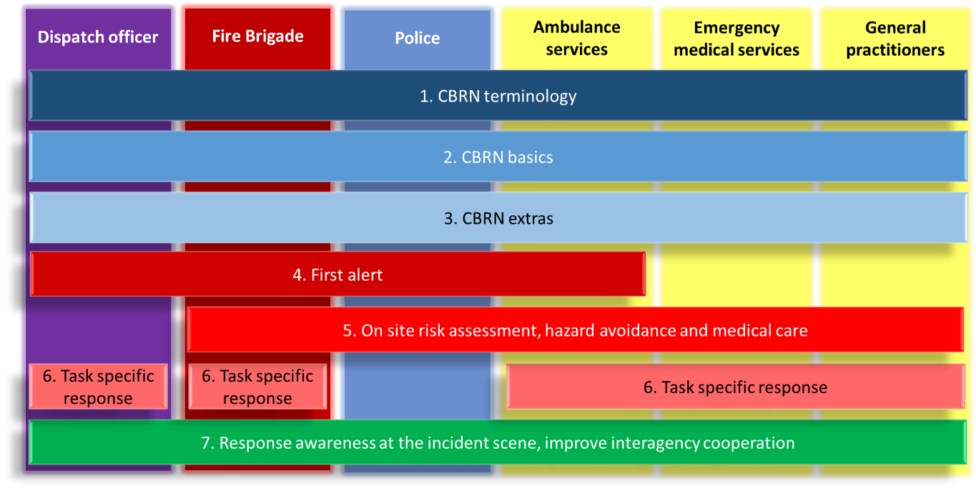Figure 1: Schematic representation of the MELODY curriculum. The three functional levels are colour-coded: basic CBRN knowledge in blue (modules 1-3), the operational level in red (modules 4-6), and the tactical level in green (module 7).*

The (basic) knowledge modules are depicted in blue and contain CBRN terminology and CBRN awareness. The material also includes CBRN extras, which might be relevant for more advanced trainees and when time allows for additional content. On top of the basics, first responders are being trained more specifically how to act at the CBRN incident scene at the operational level. These modules deal with activities to be performed on the incident scene and are depicted in red. In addition, the responders on site should not only become familiar with their own tasks and responsibilities at a CBRN incident scene, they also have to know the tasks and responsibilities of the other services present. This is necessary to support them in their task performance, and requires insight in the dependencies between the response organisations. This is the tactical level, which is represented by the final module depicted in green.

## Modules

The content of the seven modules of the MELODY curriculum is briefly summarized below. The specific learning objectives linked to each module are presented in the next section.

**Module 1: CBRN terminology**

This module explains what CBRN is. It contains definitions, the difference between accidents and attacks, and what the letters of CBRN stand for. The aim of this module is for all first responders to use the same terminology for effective communication.

**Module 2: CBRN basics**

Module 2 introduces the trainees to the general principles of CBRN, aiming for the trainees to be able to recognize a potential CBRN threat and recall how to stay safe. The ‘CBRN basics’ does not contain any practical training.

**Module 3: CBRN extras**

More in-depth theoretical knowledge will be gained when studying the optional module 3 ‘CBRN extras’. This module explains advanced information on C, B, R and N agents and provides an overview of historical use of CBRN agents and actual incidents. Furthermore, it addresses social, psychological & ethical issues.

**Module 4: First alert**

Module 4 goes into more depth and focuses on first alert. The trainees learn how to identify possible CBRN releases by asking the right questions to the person who makes the call. It includes issues such as meteorology, symptoms, and knowing which information to share with the chain of command.

**Module 5: On site risk assessment, hazard avoidance and medical care**

In module 5 the topics become more specific for different professions. First responders active at the incident scene need to be able to perform a risk assessment on scene, having in mind the information possibly provided to them by the dispatch services prior to or during moving to the incident scene. Emergency medical personnel and general practitioners will not move towards the scene but might be confronted with casualties of the incident that either self-refer to the medical facilities or are brought there by ambulances. Medical personnel should be able to estimate the risks involved in receiving and treating such potentially contaminated patients; be capable of developing a safe course of action. This module addresses all the before mentioned topics.

**Module 6: Task specific response**

In module 6 the trainees learn about task specific responses. The topics are specified for the dedicated target group. These topics go into more depth and contain practical training elements, where theoretical knowledge is applied.

**Module 7: Improve interagency collaboration**

The last module aims to improve interagency collaboration between the various emergency response services and to create response awareness at the incident scene. This module familiarizes trainees with the structure and organisation of CBRN incident management, i.e. which organizations will become involved and how they will work together. This also includes insight into the dependencies between the response organizations and therefore acts at a tactical level.

## 3.2 Learning objectives

For each module of the MELODY curriculum several learning objectives have been formulated, following Bloom’s Revised Taxonomy[3], and these are listed in Table 1.

Table 1: The learning objectives of the MELODY CBRN training curriculum. The numbers of the learning objectives are consistent throughout the curriculum, as well as the colours of the modules. Verbs originating from Bloom’s Revised Taxonomy are underlined.

|  |  |
| --- | --- |
| **#** | **Learning objective** |
| **1** | **CBRN terminology** |
| 1.1 | To recognize CBRN terminology (to be able to speak a common language) |
| **2** | **CBRN Basics** |
| 2.1 | To recognize the different groups of agents, their features and effects and list some relevant examples of incidents |
| 2.2 | To recognize a possible release and to summarize the different routes of dispersion |
| 2.3 | To recognize potential sources of CBRN agents, signs of dangerous goods, and improvised production facilities |
| 2.4 | To recall safe arrival procedures and basic safety in the field |
| **3** | **CBRN Extras** |
| 3.1 | To describe historical, ethical, sociological and scientific aspects of CBRN |
| **4** | **First alert** |
| 4.1 | To recognize signs of a potential CBRN release and (initiate first) respond(ers) |
| **5** | **On site risk assessment, hazard avoidance and medical care** |
| 5.1 | To recognize how to carry out an on-site risk assessment, zoning of the area, and isolation and registration of victims |
| 5.2 | To recognize how to carry out your work without forensic disruption of the scene |
| 5.3 | To recall some different DIM techniques |
| 5.4 | To recognize some different types of PPE and to recognize how to carry out some basic techniques |
| 5.5 | To recognize how to carry out basic decontamination procedures for people and domestic animals |
| 5.6 | To recognize how to apply appropriate medical care towards patients involved in a CBRN incident |
| **6** | **Task specific response** |
| 6.1 | To differentiate a possible CBRN incident (from normal incident) and to carry out appropriate procedures & protocols |
| 6.2 | To identify possible CBRN threats and to mitigate the effects |
| 6.3 | To familiarize with and carry out triage and provide medical care in relation to CBRN scenario's |
| **7** | **Improve interagency collaboration** |
| 7.1 | To reflect on the tasks, responsibilities and capabilities of other agencies and initiate interagency collaboration |

The first two modules of the curriculum cover the basics and therefore contain learning objectives corresponding with the first two levels of Bloom’s taxonomy: remember and understand. It is important that after these modules trainees can recognize and recall the information. This also applies to module 3 (CBRN extras).

Further in the curriculum higher cognitive levels of Bloom’s taxonomy such as ‘recognize how to carry out’ and ‘recognize how to apply’ are adopted in the learning objectives and are trained by means of practical training, scenarios and table top exercises (modules 4-7), especially in module 5 (Risk assessment and hazard avoidance)and module 6 (Task specific response). Because module 7 (Response awareness at the incident scene, improve interagency collaboration) aims to improve interagency collaboration between the different first responder services present at the incident scene, trainees will need to become familiar on how the response to CBRN incidents is organized and which organizations will become involved. A table top exercise will be the training method that is suitable for this.

# MELODY training material and training methods

Depending on the cognitive level of the learning objective MELODY training applies a range of training methods, from theoretical (e-Learning, classroom lectures, test questions) to practical training (scenario discussions, table top exercises, hands-on training); all chosen to create opportunities for learning. Table 2 provides an overview of the training methods that are applied in each module.

Table 2: Overview of training methods per module and in relation to the various learning objectives (as in Table 1 and Annex 2).

|  |  |  |  |  |  |  |  |
| --- | --- | --- | --- | --- | --- | --- | --- |
| **Training method** | CBRN terminology | CBRN Basics | CBRN Extras | First alert | Risk assessment and hazard avoidance | Task specific response | Improve interagency collaboration |
| **Classroom lectures** | 1.1 | 2.1, 2.2, 2.3, 2.4 | 3.1 | 4.1 | 5.1, 5.3, 5.4, 5.5, 5.6, 5.7 | 6.1, 6.2, 6.3 | 7.1 |
| **Test questions** |  | 2.1, 2.2, 2.3, 2.4 | 3.1 |  | 5.1, 5.2, 5.3, 5.4, 5.5, 5.6 | 6.1, 6.2, 6.3 |  |
| **E-learning** | 1.1 | 2.1, 2.2, 2.3, 2.4 |  |  |  |  |  |
| **Scenario discussions** |  |  |  | 4.1 | 5.1, 5.2, 5.4, 5.5, 5.6 | 6.1, 6.3 |  |
| **Hands-on training** |  |  |  |  | 5.4, 5.5 |  |  |
| **Table top exercise** |  |  |  |  |  |  | 7.1 |

In support of the trainer, different types of training material have been developed for each learning objective and these are further discussed below. The list of available MELODY training material can be seen in Annex 2 (listed per learning objective and module), where the addition of “Test” after the number indicates test questions and “P” after the number indicates practical training in form of scenario discussion, hands-on training or table-top exercise. All this material can be downloaded from the MELODY website ([www.melodytraining.eu](http://www.melodytraining.eu)) either in MS Word or MS PowerPoint digital format.

In addition, a card game has been created as an informal instrument to recapitulate or to test the gained knowledge.

## 4.1 Theoretical training

### 4.1.1 Classroom presentations

All seven modules of the curriculum have theoretical training elements, which can be delivered in form of classroom lectures. A series of PowerPoint presentations is available for this purpose. Annex 2 shows, which of these presentations are relevant for reaching a given learning objective. Each PowerPoint presentation consists of a series of slides to be used during the lecture and with additional information for the trainer included in the slide notes. This information lists not only the overarching learning objective and the intended learning outcome of the respective slide, but also includes suggestions for the trainer on how to present the subject matter and where to find more background information. Furthermore, suggestions are included as to when and how to interact with the trainees (marked with a “?” in the slides).

**Note 1:** Many times the trainer can and should adapt the contents of the presentations to the national context. Places in the material for such adaptations are indicated by a black flag. Adaptations could be including examples of incidents from their own country or talking about national standard operating procedures rather than about the once included in the MELODY material. A more detailed explanation on how to use the classroom presentations can be found in Annex 3.

**Note 2:** Classroom presentation 7.1 contains an interactive element, namely an interagency collaboration exercise. More information about this exercise can be found in Annex 4.

### 4.1.2 E-learning

For module 1 (Terminology) and module 2 (CBRN basics) an e-learning was developed. In these modules, trainees will be trained in the very basic knowledge on the general principles of CBRN, aiming the trainees to recognize a potential CBRN threat and recall how to act. In case of limited time available for on-site training, the e-learning can replace the classroom lectures; the content is largely the same. In this way trainees can perform a self-study prior to on-site training, ensuring a basic level of CBRN knowledge with all trainees when performing the on-site training. The e-learning is responsive to the screen size, so accessible on a smartphone, tablet and laptop and contains interactive parts and quizzes. The e-learning can be accessed through the MELODY website ([www.melodytraining.eu](http://www.melodytraining.eu)) and is available in several languages.

If resources are available, a training organization can choose to integrate the e-learning in an online learning platform, which will allow the trainer to interact with the trainees and to supervise their progress.

### 4.1.3 Test questions

For most learning objectives a “Test” component is available, i.e. a number of questions for the trainees to check, if they fully understood the content. The trainer can use these questions in different ways: to be answered individually or groupwise, as basis for plenary discussions, after each lecture or after the set of lectures for a specific learning objective, as exam or as opening questions for a refresher course etc.

## 4.2 Practical training

For all learning objectives with ‘recognize how to apply’ and ‘recognize how to carry out’ the curriculum foresees some form of practical training (scenario discussions, hands-on training or table top exercise) in addition to one or several classroom lectures. Supportive training material, marked with a “P” in Annex 1, is available for such training, e.g. 4.1 P, 5.1P, etc.

### 4.2.1 Scenario discussions

The aim of the scenario discussions is that trainees bring the theory they just have learned into practice. Trainees have to get familiar with signs and signals and have to practice in recognizing potentially useful information from the presented scenarios. Trainees will be trained to extract CBRN-related information when inquiring about an incident, thus, to be aware of potential CBRN risks. The trainer can decide, which scenarios to discuss and – depending on the chosen learning objectives – which information and questions to include for each scenario. Note also that these discussions can be performed in various settings, either simply in a classroom, with or without additional prop, or in a physical mock-up environment that provides more realism to the discussion.

Further guidance on how to use the training material for scenario discussions and how to lead a scenario discussion can be found in Annex 5. There, you can also find a list of scenario topics, learning objectives covered, target audience, type of CBRN agent concerned and level of complexity.

### 4.2.2 Table top exercises

The aim of the table top exercises is similar to that of scenario discussions with a special focus on interagency collaboration. This generally indicates that the scenario of a table top exercise is more complex and will evolve throughout the exercise by introducing injects with new information on the incident. More material such as a map of the area to explain the situation will be required. This and other material, such as instructions, playing cards and supporting forms, are available. Information is provided for trainers on how to set-up, prepare and execute an exercise. Table top exercises are part of module 7, to practice interagency collaboration. More information on the organisation of a table top exercise can be found in Annex 6.

### 4.2.3 Hands-on training

By hands-on training trainees learn to apply their knowledge. Two such elements are included in the MELODY curriculum, 5.4P and 5.5P (see Annex 2). After a short introduction by the trainer, the trainees will perform actions themselves. It is important to plan the hands-on training well in advance, as certain props such as disposable gloves are needed to conduct the training. Some hands-on trainings include short videos with examples that can be found on the MELODY website ([www.melodytraining.eu](http://www.melodytraining.eu)). The trainer is advised to assess if the MELODY hands-on training is in line with the corresponding protocols in their organization and country.

## 4.3 The MELODY Mind card game

To cope with the limited time first responders have for their training and education, as well as the probable low amount of CBRN events first responders will face, a card game was developed, that will serve as an enchiridion, glossary and knowledge back-up, to repeat by an approachable playful manner what has been taught. This card game can be played any time, any place. The game is questions based and can be played with a small group, in teams, or even individually. The game is available in multiple languages and can be purchased through the MELODY consortium.

# How to use the curriculum and compose a MELODY training

The MELODY CBRN training curriculum applies a modular approach to facilitate flexibility in content, training hours, target audience, and training methods. A short animation has been produced that explains how to use the MELODY curriculum and to compose a training tailored to the needs of the target audience. The animation can be found on the MELODY website ([www.melodytraining.eu](http://www.melodytraining.eu)).

Which learning objectives, training material and training methods to select for a specific training occasion or course, will depend on several factors, such as the needs and preferences of the target group of trainees, the time and resources available for training, and the preference of the trainer. Although the MELODY training material has been developed for specific training methods and specific learning objectives, it is up to the trainer exactly how he/she wants to convey the subject matter to the trainees. It is also possible for the trainer to include his/her own pre-existing training material to supplement the MELODY training material as long as it supports reaching the MELODY learning objectives.

Further, trainers and training coordinators can assemble a MELODY training program of consecutive courses that are spread over a longer period and that together cover the entire MELODY curriculum. Individual training elements such as the e-learning, test questions, a scenario discussion and not the least the MELODY MIND card game are suitable for refresher courses or simply to keep the knowledge “alive” between courses and real incidents.

## 5.1 Guidance on how to compile a training course tailored to the trainees needs

To tailor a training to the needs of the trainees, the trainer can answer the following questions:

Whom do you want to train? How much prior CBRN knowledge can you expect from these trainees?

Select relevant learning objectives for the target audience, based on the indicated target audience per learning objective as displayed in annex 2.

On what topics do you want to focus?

Adjust your previous selection by removing learning objectives that are not relevant for the aim of the training.

How much time have you got for your course? What resources in form of trainer colleagues, indoor/outdoor facilities, digital solutions do you have available?

Adjust your previous selection by removing learning objectives if needed and deciding how to deliver the training. Extend time spent on specific learning objectives by increasing for example the number of scenario discussions or time for reflective test questions and group work. Decide if you want different trainers for different parts, scenario discussions in classroom setting or in mock-up environment, with certain parts in a digital online format, etc.

Maybe your organisation uses an online learning platform. In that case you might want to set up the MELODY e-learning in a manner that allows you to interact with and to supervise your trainees while they are learning. You could also transfer MELODY classroom lectures into webinars and integrate these in your learning platform.

What adaptations to the national situation and which examples will be needed to align the content of the training to the national situation?

Decide on interesting (recent) examples reflecting situations that are likely to be faced by the trainees in their daily job, and replace MELODY procedures for national procedures in case these diverse.

See **Annex 7** for examples of how to compose different trainings tailored to different target audiences by selecting specific components of the curriculum and by using different training methods.

# Tips & Tricks

Below you can find some general tips and tricks when preparing a training:

* Keep in mind that the preparation of a tailored training takes time. You need to study the training material, include national examples where possible, prepare the chosen scenarios, check the additional information included in the scenarios, prepare hands-on training, you might require to purchase some of the needed equipment for your training. Estimate the time it will take to give the training, taking into consideration time for interaction and discussion, breaks and evaluation time.
* There is an adaptable figure of the schematic representation of the MELODY training structure. In this way you can show the trainees a schematic overview of the training you have composed.
* Present clear structures and frames and expectations for the MELODY course so the trainees can focus on their learning and involvement rather than practical issues. Clarify it is learning and collaboration, not assessment of their knowledge and skills, that are in focus and that it is a joint responsibility for discussions and collaboration to be fruitful.
* Clarify the overarching aims of MELODY and the learning objectives to the trainees to facilitate goal fulfilment and meaning-making.
* Round off the different Modules with a take home message and a reminder of the learning objective.
* Try to make the training interactive and always try to include practical components. Especially in case of limited time, try not to cram the training only with classroom training, but include training components where trainees need to apply the knowledge.
* Remember that trainee activity and active involvement in discussions benefits learning and that a climate where the trainees are allowed to freely share ideas and perspectives without the need of immediately know the "right" answer will benefit learning.
* If possible, use own experiences or (inter)national incidents as examples to the topics in the course.
* If you have multiple screens available during your training, you can use PowerPoint Presenter View. It shows you the current slide, the next slide, the slide number, presentation time and your speaker notes.

# Annex 1: Background

Previous incidents involving CBRN agents have demonstrated the relevance of those in the first line of action (first responders) being aware and recognizing a CBRN incident, as well as being prepared on how to act safely. A CBRN incident can be caused by an accident or negligence, but also by deliberate release of CBRN agents or in rare cases a terrorist attack. According to the new EU CBRN action plan (2017), “terrorist organisations have not used chemical, biological, radiological and nuclear ("CBRN") agents in Europe. Still, there are credible indications suggesting that terrorist groups might have the intention of acquiring CBRN materials or weapons and are developing the knowledge and capacity to use them”[4]. The credibility was demonstrated by two incidents in 2018, the poisoning of a former Russian military officer and double agent for the UK's intelligence services, and his daughter, with a Novichok nerve agent and the arrest of an inhabitant of the city of Cologne, Germany, who manufactured an explosive device with incorporated the highly toxic substance ricin. The scope of the curriculum comprises intentional and unintentional releases of CBRN, or threats thereof, which require immediate action.

Ideally, CBRN training curricula in Europe do not differ between countries, but are harmonised across Europe. The MELODY curriculum will contribute to this: the harmonized CBRN training curriculum is defined, developed and deployed for first responders and medical staff (Fire brigade, (Military) police, Ambulance services, Dispatch officers, Emergency Medical Services, General Practitioners) based on their needs identified in the first phase of the project. The training is provided in such a way that all agencies will all have a common operational picture and work as a team together. Training together is important for efficient collaboration and awareness on the scene.

The curriculum is designed, developed, tested, improved and quality assured by collaboration of CBRN experts present in the MELODY consortium together with four European training centres for first responders. Training programs, curricula and materials already exist, both at national and European level, were taken into consideration, as well as what is being used and valued by training institutes in Europe, practitioner’s needs and possible cultural differences.

# Annex 2: The MELODY CBRN training curriculum (detailed)

|  |  |  |  |  |  |  |  |  |  |  |  |
| --- | --- | --- | --- | --- | --- | --- | --- | --- | --- | --- | --- |
| **Number** | **Learning objective** |  | **Presentations** | **DO** | FB | P | AS | EMS | GP# | Time (min) |  |
| **1** | **CBRN Terminology** | | | | | | | | | | **Available as e-learning** |
| 1.1 | To recognize CBRN terminology (to be able to speak a common language) | 1.1 | What is CBRN (definitions; accidents v. attacks; C v. B v. RN) | X* | X | X | X | X | X | 15 |
| **2** | **CBRN Basics** | | | | | | | | | |
| 2.1 | To recognize the different groups of agents, their features and effects and list some relevant examples of incidents | 2.1.1 | Classification, properties, dispersion (including explosives), signs and triggers, etc. | X | X | X | X | X | X | 25 |
| 2.1.2 | Some relevant examples of incidents | X | X | X | X | X | X | 10 |
| 2.1 Test | Test Questions | X | X | X | X | X | X | 10 |
| 2.2 | To recognize a possible release and to summarize the different routes of dispersion | 2.2.1 | Routes of exposure, symptoms, etc. | X | X | X | X | X | X | 25 |
| 2.2.2 | Dispersion of CBRN agents | X | X | X | X | X | X | 20 |
| 2.2 Test | Test Questions | X | X | X | X | X | X | 10 |
| 2.3 | To recognize potential sources of CBRN agents, signs of dangerous goods, and improvised production facilities | 2.3.1 | Where can you find CBRN materials? (industry, health care, research facilities, etc.) | X | X | X | X |  |  | 25 |
| 2.3.2 | Dangerous goods and UN codes | X | X | X | X |  |  | 25 |
| 2.3.3 | How can you recognize illegal production or use of CBRN materials? | X | X | X | X |  |  | 35 |
| 2.3 Test | Test Questions | X | X | X | X |  |  | 10 |
| 2.4 | To recall safe arrival procedures and basic safety in the field | 2.4.1 | Arriving safe at the scene (access routes, hot zone, wind direction, etc.) | X | X | X | X |  |  | 25 |
| 2.4.2 | Basic safety in the field (rules of thumb, zoning, etc.) | X | X | X | X |  |  | 10 |
| 2.4.3 | Own safety in the field (personal protection) | X | X | X | X |  |  | 25 |
| 2.4 Test | Test Questions | X | X | X | X |  |  | 15 |
| **3** | **CBRN Extras** | | | | | | | | | |  |
| 3.1 | To describe historical, ethical, sociological and scientific aspects of CBRN | 3.1.1 | Elaborated history: development of agents, actual incidents the past & context | X | X | X | X | X | X | 45 |  |
| 3.1.2 | Social, psychological & ethical issues (e.g. moral issues, rescue victims versus own risks, isolation/separation of possible contaminated people, child-parent separation, aftercare) | X | X | X | X | X | X | 25 |  |
| 3.1.3 | Advanced information on C, B, R and N agents | X | X | X | X | X | X | 50 |  |
| 3.1 Test | Test questions | X | X | X | X | X | X | 20 |  |

|  |  |  |  |  |  |  |  |  |  |  |
| --- | --- | --- | --- | --- | --- | --- | --- | --- | --- | --- |
| **Number** | **Learning objective** |  | **Presentations** | **DO** | FB | P | AS | EMS | GP# | Time (min) |
| **4** | **First Alert** | | | | | | | | | |
| 4.1 | To recognize signs of a potential CBRN release and (initiate first) respond(ers) | 4.1 | Identify possible CBRN releases by asking the right questions to the person who makes the call, including issues such as meteorology, wind, symptoms, and knowing which information to share with chain of command (escalation protocol). | X* | X | X | X |  |  | 40 |
| 4.1 P | Scenario discussions: Identify possible CBRN releases by asking the right questions | X | X | X | X |  |  | 15/scenario |
| **5** | **Risk assessment and hazard avoidance** | | | | | | | | | |
| 5.1 | To recognize how to carry out an on-site risk assessment, zoning of the area, and isolation and registration of victims | 5.1.1 | Preparations for on-site arrival, en-route (upwind) approach, incident analysis. On-site risk/threat assessment. |  | X | X | X |  |  | 35 |
| 5.1.2 | Security of the area, upwind approach (including traffic control), hot zone, warm zone, cold zone |  | X | X | X |  |  | 40 |
| 5.1.3 | Isolate people and domestic animals on scene |  | X | X | X |  |  | 15 |
| 5.1.4 | Registration of victims |  | X | X | X |  |  | 25 |
| 5.1 Test | Test questions |  | X | X | X |  |  | 15 |
| 5.1.P | Scenario discussions: Arrival on-site: security, isolation and registration of victims |  | X | X | X |  |  | 15/Scenario |
| 5.2 | To recognize how to carry out your work without forensic disruption of the scene | 5.2 | Forensic awareness |  | X | X | X | X | X | 40 |
| 5.2 Test | Test questions |  | X | X | X | X | X | 10 |
| 5.2.P | Scenario discussions: Forensic awareness |  | X | X | X | X | X | 15/Scenario |
| 5.3 | To recall some different DIM techniques | 5.3 | Detection, Identification and Monitoring (DIM) |  | X | X | X | X |  | 15 |
| 5.3 Test | Test questions |  | X | X | X | X |  | 10 |
| 5.4 | To recognize some different types of PPE and recognize how to carry out some basic techniques | 5.4 | Personal protective equipment (PPE) |  | X | X | X | X |  | 20 |
| 5.4 Test | Test questions |  | X | X | X | X |  | 10 |
| 5.4.P | Hands-on training: Personal protective equipment (PPE) |  | X | X | X | X |  | 45 |
| 5.5 | To recognize how to carry out basic decontamination procedures for people and domestic animals | 5.5 | Decontamination (of people and domestic animals) |  | X | X | X | X |  | 20 |
| 5.5 Test | Test questions |  | X | X | X | X |  | 10 |
| 5.5.P | Hands-on training: Decontamination (of people and domestic animals) |  | X | X | X | X |  | 90 |
| 5.6 | To recognize how to apply appropriate medical care towards patients involved in a CBRN incident | 5.6 | Treatment methods of patients involved in a CBRN incident |  | X | X | X | X | X | 30 |
| 5.6 Test | Test questions |  | X | X | X | X | X | 10 |
| 5.6.P | Scenario discussions: Treatment methods of patients involved in a CBRN incident |  | X | X | X | X | X | 15/Scenario |

|  |  |  |  |  |  |  |  |  |  |  |
| --- | --- | --- | --- | --- | --- | --- | --- | --- | --- | --- |
| **Number** | **Learning objective** |  | **Presentations** | **DO** | FB | P | AS | EMS | GP# | Time (min) |
| **6** | **Task specific response** | | | | | | | | | |
| 6.1 | To differentiate a possible CBRN incident (from normal incident) and to carry out appropriate procedures & protocols | 6.1 | How to recognize possible CBRN release and initiate alarm protocol [COUNTRY BASED] | X* |  |  |  |  |  | 30 |
| 6.1 Test | Test questions | X |  |  |  |  |  | 5 |
| 6.1.P | Scenario discussions: How to recognize possible CBRN release and initiate alarm protocol [COUNTRY BASED] | X |  |  |  |  |  | 15/scenario |
| 6.2 | To identify possible CBRN threats and to mitigate the effects | 6.2 | Mitigation methods to limit dispersion, including decontamination |  | X |  |  |  |  | 75 |
| 6.2.Test | Test questions |  | X |  |  |  |  | 5 |
| 6.3 | To familiarize with and carry out triage and provide medical care in relation to CBRN scenario's | 6.3.1 | Triage related to CBRN |  |  |  | X | X | X | 40 |
| 6.3.2 | Medical treatments, countermeasures and protection (see also 5.3) |  |  |  |  | X | X | 60 |
| 6.3 Test | Test questions |  |  |  | X | X | X | 30 |
| 6.3.P | Scenario discussions: Triage and medical treatment related to CBRN |  |  |  | X | X | X | 15/scenario |
| **7** | **Improve interagency collaboration** | | | | | | | | | |
| 7.1 | To reflect on the tasks, responsibilities and capabilities of other agencies and initiate interagency collaboration | 7.1 | Elaborate on tasks of other responders at CBRN scene, and their value. | X | X | X | X | X | X | 60 |
| 7.1.P | Table top exercise on interagency collaboration | X | X | X | X | X | X | 150 |

# DO – Dispatch officer; FB – Fire brigade; Police – Police officer; AS – Ambulance services; EMS – Emergency medical services; GP - General practitioner.

* X – Marks the target groups, for which the training materials have been developed. However, topics might suit non-listed target groups too, as well as other professions, such as coast guard, customs, soldiers, red cross, etc.

# Annex 3: Classroom presentations

Classroom presentations are available for all modules. It is important that after delivering the classroom presentation, trainees can recognize and recall the information.

## Material

This classroom presentation material consists of a series of PowerPoint presentations, covering all 7 modules of the curriculum. For every learning objective, a set of one to three classroom presentations have been developed in PowerPoint. For the classroom lectures the following equipment is required:

* Computer and projector
* The MELODY PowerPoint presentations
* Trainer’s notes to PowerPoint presentation
* Handouts of the PowerPoint presentations for the trainees, not containing the notes.

The presentations are available on the MELODY website ([www.melodytraining.eu](http://www.melodytraining.eu)).

## Notes for trainer

Every slide in the PowerPoint presentations is provided with the same framework of notes to guide the trainer through the slide (see Figure A3.1). The notes instruct the trainer how the information on the slide may be presented. The notes will start with general information on the topic concerned, which is the same for all slides within this topic and includes:

**Module**: Module title

**Learning objective**: As included in the module outline

**MELODY Presentation**: Number and title of the presentation

**Target Audience**: First responder groups the presentation was developed for

This part is followed by notes regarding slide specific information. There is an instruction for trainers and information on the result after training the slide:

**Title slide**: Title of slide x

**Result**: Description of what the trainees should know after training of slide x

**Instructions for the trainer**: Explain the trainer what to train the content of the slide and in which manner

**Next**: Follow up action

Please note that the instruction for trainers varies from a short instruction to a full narrative, resulting in differences in openness for own interpretation and examples. It is important to adhere to the learning objectives and to be aware of details that will be discussed in other modules.

The third part of information deals with specific information related to the content of the slide and includes:

**References for additional information**: If available, a link to background information

**Depicted illustration**: Information on the pictures used in the slide

**Picture source & IP**: Source and IP information of the pictures on slide x

**Text source & IP**: Source and IP information of the text on slide x

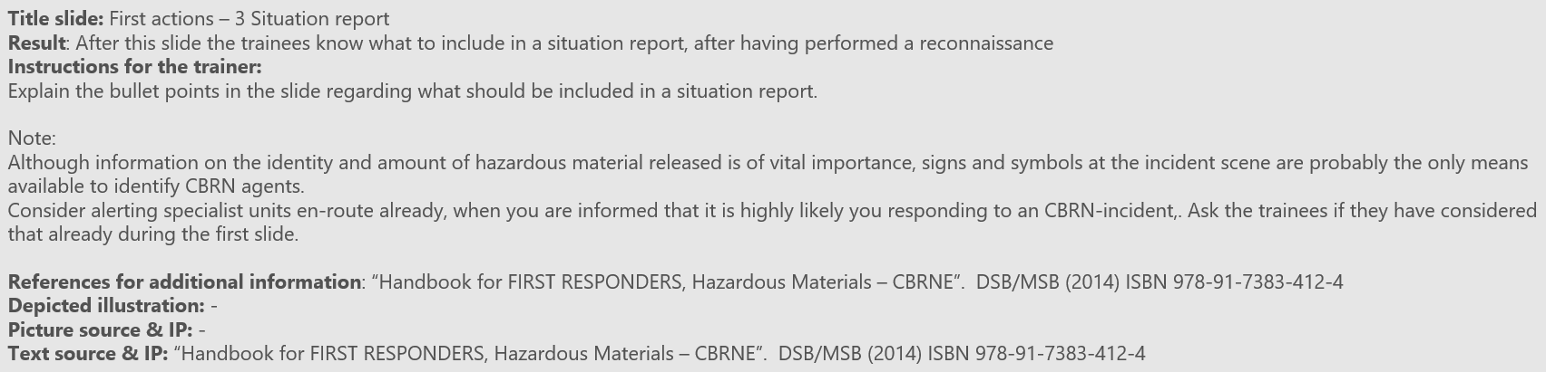

*Figure A3.1: Example of part of Notes accompanying every slide of the curriculum, to guide the trainer through the presentation*

## Flag or question mark

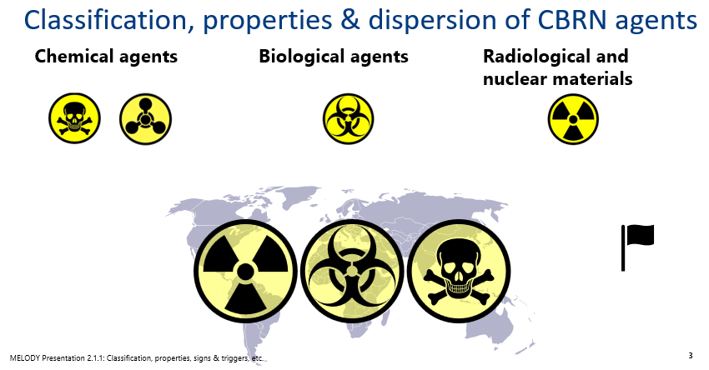Some slides include a ‘question mark’, which means that this slide is an introduction to an interactive discussion with the trainees to reflect on the topic concerned. Other slides are tagged with a flag, which means that adaptation of the slide is required to adapt the content to the national situation (see Fig A3.2). This might be e.g. some national examples of CBRN incidents or country specific information on the organisation of response structures.

*Figure A3.2: Example of a slide with a flag, indicating an advise to include national examples.*

While presenting, the trainer should give the trainees ample opportunities to ask questions. At certain slides the instructions suggest to hold a discussion with the trainees. Trainers are encouraged to use these suggestions and other opportunities to increase trainee activity levels and provide feedback to the trainees. In most non-obvious cases, a “desired outcome” of the discussion will be mentioned. Trainers should try to guide the trainees towards this outcome. However, the discussion itself is more valuable than the outcome.

## Test component

Most modules have a “Test” component, indicated with “Test” behind the number of the learning objective. This is a number of questions to be given to the trainees. The test component can be used either as an assessment to check if the trainees have fully understood the material or can give the trainees an idea of how they performed (formative testing rather than summative testing). If possible, have the trainees answer the questions individually, followed by a discussion about the correct answers. Another possibility is to discuss the questions in small groups or with all trainees together. The trainees’ knowledge can also be assessed in practical training, where the knowledge obtained in-classroom training will be applied in practice through a scenario discussion, hands-on training or table top exercise. The trainer may decide how to use the test component.

Annex 4: Interagency Collaboration Exercise

## Aim of the exercise

The aim of the exercise is to introduce first responders from one organization to the tasks and activities of another first responder organization. In an interactive setting a discussion is held about the different perceptions, tasks and activities of first responder organizations. This to better understand the other first responder organisations, its capabilities and possible limitations.

This exercise meets the MELODY learning objective: Improve interagency collaboration

**Duration of the exercise:** Approximately **45 minutes**

### Personnel

* One trainer/facilitator to introduce the exercise, facilitate discussion and wrap up the exercise.

### Materials

* MELODY guide for trainers (this document).
* PowerPoint presentation to be used by the Trainer/facilitator to guide the participants through the exercise.

*MELODY 7.1. Awareness and interagency collaboration_V2.1_20211101.pptx*

* Three large papers (A0 format), one with heading 'fire department’, one with heading ‘police’ and one with heading ‘ambulance’. Each paper divided in two parts: the topside for the own tasks at a CBRN incident, and the bottom for the tasks of another first responder organization that respective organisation thinks is responsible for.
* Yellow, pink and blue post-its (10 of each colour for each participant).

### Workflow

The interagency collaboration exercise consists of five steps:

**Step 1:** (5 minutes)

The Trainer/facilitator presents the assignment to the participants using the provided PowerPoint of module 7.1:

‘Write on Post-its all specific CBRN task you/ your response organisation have (colour A-yellow), and the CBRN tasks that (you think) other first responder organizations have (colour B-pink). Yellow Post-it notes should be placed in the top section and pink Post-it notes on the lower halve of the overview paper (see Figure A4.1).

If needed, the trainer can use parts of the PowerPoint presentation to refresh the tasks and responsibilities of various response organisations.

The group is then divided into subgroups, based on the organisation they belong to.

**Step 2:** (5 minutes)

Give all participants 5 minutes to place their contributions on the central positioned flip-overs.

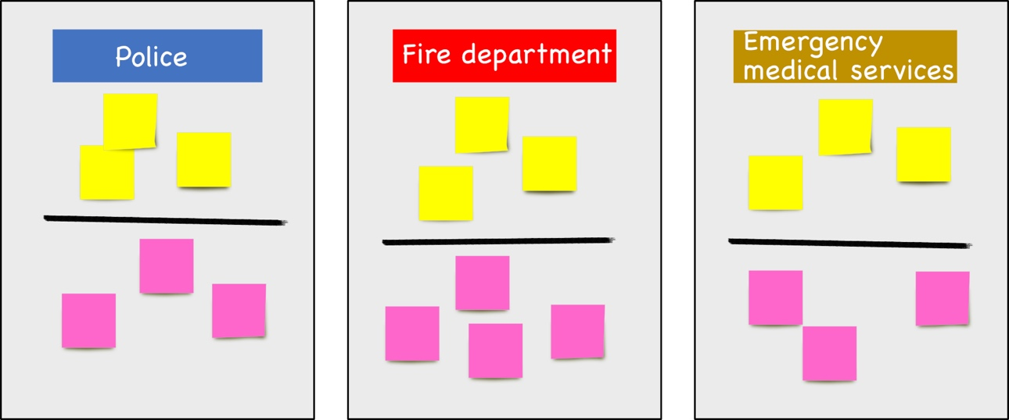

Figure A4.1: Overview flaps to add tasks of own first responder organisation and other first responder organisations

**Step 3:** (15 minutes)

When finished adding contributions on the flip-over, a central discussion is held by the trainer to elaborate, check, and extend the contributions to enhance mutual understanding of the tasks and roles of first responder organizations during a CBRN incident. The trainer invites the participants to discuss the differences between actual tasks (yellow post-its) and the perceived tasks (pink post-its) and link it to the provided MELODY overview. The facilitator can use the questions provided in Table A4.1 to initiate the discussion.

Table A4.1: Suggested questions to initiate discussion between participants

|  |  |
| --- | --- |
| Melody topic | Suggested discussion question |
| Own first responders CBRN tasks | * Could you elaborate on the CBRN tasks that you are responsible for? * Is it clear what tasks need discussion in order to organize an adequate response? * When you are aware of this, what does this mean for your interagency collaboration? * If tasks are not clear, who could provide within your organization clarification about the CBRN tasks? |
| CBRN tasks other first responder organizations | * Could you elaborate on the CBRN tasks that the other first response organization are responsible for? * Do the perceived tasks match with the actual tasks?   + What are the differences? * What do you expect from the other organisation and what dependencies do you have? * What is important for the other first responder organizations to know about your tasks? For example:   + Limitations of the capability   + Duration before capability is operational * If tasks of other response organizations are not clear, who could provide clarification about the CBRN tasks?   + In preparation phase   + During operation |

**Step 4:** (15 minutes)

The participants are asked to write down the name of specialized CBRN response units that could be required in the response to a CBRN incident and place them on the flip-overs (5 minutes), either in one of the already available columns or next to them if they are not associated to police, fire department or emergency medical services. The trainer discusses the added blue Post-its with the additional specialist units that could assist in the response to a CBRN incident (10 minutes) (Figure A4.2). The facilitator can use the examples presented in the provided PowerPoint.

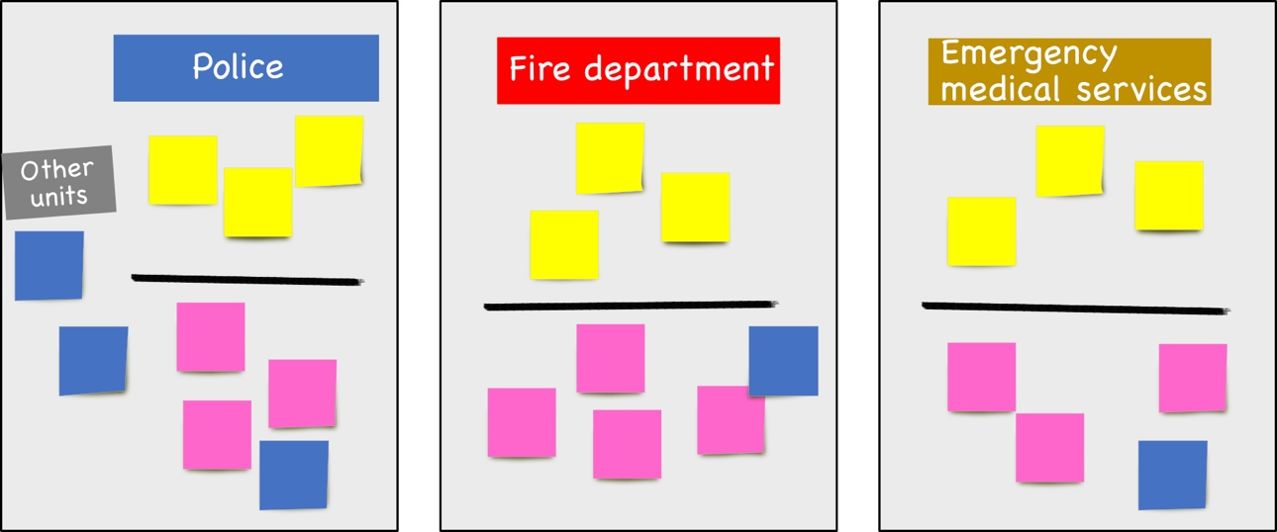

Figure A4,2: Added blue post-its to the various columns.

**Step 5:** (2 minutes)

The trainer wraps up the discussion and summarises the most important lessons learned.

# Annex 5: Scenario discussions

Aim of the scenario discussions is that trainees bring the theory they just have learned into practice. Trainees have to get familiar with signs and signals and have to practice in recognizing potential useful information from the presented scenarios. Trainees will be trained to extract CBRN-related information when inquiring about an incident, thus, to be aware of potential CBRN risks. The trainer can decide on which scenarios to discuss and how to lead the scenario discussions depending on the availability of training material, the available organizations in the training and the experience of the trainees.

Scenarios will present the trainees typical emergency situations that they can encounter in their daily operations, as well as more complex scenarios. The intent is to assess the ability to logically manage the scenario and to discuss, in a stress-free environment, which would be the first steps in the response to an event that may involve the presence of CBRN agents.

Bear in mind that scenarios have to be discussed in an open environment where there is no correct answer on how to they should act when confronted with such an incident. The main purpose is to discuss their approach and why they would act in such a way. Varying viewpoints, even disagreements, are to be expected. Trainees should respond to the scenario’s using their own knowledge and capabilities (i.e. they may only use existing assets) and the insights derived from the training. The trainer has to remind them that decisions are not precedent settings and may not reflect organization’s final position on a given issue. This exercise is an opportunity to discuss and present multiple options and possible solutions.

The trainer can decide on how to organize the scenario discussions. This may depend on the first responder services attending the training, the scenarios to be discussed as well as the time available for training. Preferably, scenarios are to be discussed in small groups of trainees (between 2 and 5). This enables them to hear and reflect on each other’s views. Debriefing of the subgroups discussions to the entire group will increase the exchange of thoughts and ideas on how to act in a certain CBRN-related situation. The trainer should reserve 5 – 10 min per scenario. Depending on the type of application the trainer should reserve smaller or larger timeslots to allow for discussion and debriefing after the discussion in a plenary setting.

Scenarios can be presented to the trainees in several ways. Scenarios can be described, which may be a realistic setting for a dispatch officer’s situation, but can also be more visualized by pictures and situation overviews, being more realistic for the first responder services present at the incident scene. Alternatively, scenarios can be demonstrated, if this is feasible in the training facility. A drugs lab, powder letter delivered at an office, a chemical substance illegally transported in a car or van can be easily set up in a demonstration setting, making it more realistic for the trainees, e.g. they have to decide whether it is safe to come closer to check the suspicious situation or to call for assistance.

A set of scenarios has been developed, covering the various relevant dimensions (C, B and R, intentional and accidents). Most of the scenario’s focus on incidents with an actual incident location but some are focusing on the response from emergency medical services at hospitals or at general practitioners’ offices. An overview of the scenarios is listed in the table below. The trainer has to choose which scenarios will be most suited for the audience attending his training.

For every scenario, a word document has been developed that outlines besides the scenario, also the complexity, target audience and aim of the scenario discussion per module. The actual training material of the specific scenario is a PowerPoint presentation that covers all slides for the training and guidance on how to lead the scenario discussion for that specific scenario. Which information is available for which learning objective is shown in table A5.1 below. The word and PowerPoint presentations can be found on the MELODY website ([www.melodytraining.eu](http://www.melodytraining.eu)).

In the word-document the following information is described for the following learning objectives.

**4.1 P: Scenario discussions on the interaction between dispatch officer and caller**

**Aim:** The dispatch officer interacts with the caller to identify the likelihood of a possible CBRN release and to know which information should be shared with the chain of command. Use of METHANE and Four W’s protocols.

**5.1 P: Scenario discussion on the interaction between dispatch officer and First responder moving towards the incident scene**

**Aim:** The first responders arrive on scene, perform a risk assessment, talk with the caller, perform a reconnaissance of the incident scene and discuss actions. They apply METHANE, establish zoning, isolate people and domestic animals, initiate evacuation, register persons.

* 1. **P: Scenario discussion on forensic awareness at the incident scene**

**Aim:** The responders discuss the possible forensic value of the materials found on the scene and preserve the evidence.

**5.6 P:** **Scenario discussion on the treatment methods and triage of patients at the incident scene**

**Aim:** The responders assess the medical conditions of the victims and perform medical triage on the victims based on provided symptoms.

**6.1 P: Scenario discussion on the interaction between dispatch officer, caller and first responders**

**Aim:** The dispatch officer interacts with the caller and relays necessary information to the responders moving towards the scene.

**6.3 P: Scenario discussions on the treatment methods and triage for large scale incidents**

**Aim:** The responders assess the medical conditions of the victims and perform medical triage on the victims based on provided symptoms using MASS triage.

A set of scenarios has been developed that can be used for the various applications mentioned above and covering the various relevant dimensions (C, B and R, intentional and accidents, ). Most of the scenarios focus on incidents with an actual incident location but some are focusing on the response from emergency medical services at hospitals or at general practitioners’ offices.

## How to select and prepare a scenario discussion

In this section an example is provided on how a trainer can prepare for a scenario discussion.

When preparing a scenario discussion on a certain application, the trainer selects which scenario he/she would like to run depending on the present first responder services and their experience. The trainer can then select the associated slides from the overview presentation as well as the more general introduction slides. If the trainees are unfamiliar with scenario discussions some slides need to be added introducing the aim of the discussion. Each presentation consists of:

* A general introduction to the scenario discussions and the aim of the topic
* The actual scenario description and the relevant information for the discussion on the specific topic
* Additional guidance that can be provided if the trainees require some assistance

**Example:**

The trainer has just finished the classroom presentations on the arrival on scene modules of the MELODY curriculum and wants to test the trainees and evaluate if they can apply the information they learned in an incident scenario. As this is their first scenario discussion and they are relatively inexperienced with the topic of CBRN, the trainer selects an easy scenario to warm up the trainees and schedules some additional time to introduce the approach to the scenario discussion. The trainer therefore selects the PowerPoint for the scenario discussion on arrival on scene, the general introduction is kept. The trainer then hides all the slides of those scenarios he/she does not intend to use. He/she selects an easy scenario to start with (truck with a smoking engine) and a scenario with a moderate complexity (illegal drugs lab).

The trainer then introduces the scenario discussion, the aim of the discussion and assignment, divides the group in smaller groups and asks them to assign a presenter that can feedback the outcomes in the plenary session afterwards. The trainer then presents the first scenario asking the groups to perform their assignment. The trainer notices that most of the groups are performing their assignment well but one group is a little struggling with the topic and thus provides some additional guidance material in the form of a couple of handouts containing the METHANE method and the 1-2-3 rule to help them along.

After the first assignment the trainer discusses the outcomes of the various groups in a plenary session by asking each group to briefly present their work and outcomes of their discussion.

Once the plenary discussion is finished the trainer proceeds with the introduction of the second scenario and again asks the trainees to perform their assignment with the new scenario. In the second scenario a group is asking for some more details on the scenario as this information will help them to perform their assignment. The trainer refers to the complete description of the scenario that he/she has available on the members login part of the MELODY website ([www.melodytraining.eu](http://www.melodytraining.eu)) and provides some relevant details to allow the group to continue their discussion.

*Table A5.1: Scenario overview describing the type of incident, complexity, intentional or accidental release, target audience and modules and learning objectives covered by the scenario.*

|  |  |  |  |  |  |  |  |  |  |  |  |  |
| --- | --- | --- | --- | --- | --- | --- | --- | --- | --- | --- | --- | --- |
| **Number** | **Scenario** | **Type** | **complexity** | **accident/ intentional** | **Involved target audiences (Dispatch, Fire, Police, Ambulance, GP, EMS)\*** | **First alert** | **Risk assessment & hazard avoidance** | | | **Task specific response** | | **Interagency collaboration** |
|  |  |  |  |  |  | Asking | Arrive | Forensics | Medical | Alarm | Medic | TTX |
|  |  |  |  |  |  | **4.1 P** | **5.1 P** | **5.2 P** | **5.6 P** | **6.1 P** | **6.3 P** | **7.1 P** |
| **1** | Illegal drugs lab | C | moderate | accident | Fire, police, dispatch, ambulance | X | X | X | X | X |  |  |
| **2** | Dredging incident | C | moderate | accident | Fire, police, ambulance | X | X | X | X | X |  |  |
| **3** | Dirty bomb at a pet fair | R | complex | intentional | Fire, police, dispatch, ambulance | X | X | X | X | X |  |  |
| **4** | Powder at celebrity house | B | moderate | intentional | Fire, police, dispatch, ambulance | X | X | X | X | X |  |  |
| **5** | Chem attack in city center | C | complex | intentional | Fire, police, dispatch, ambulance | X | X | X | X | X | X |  |
| **6** | Prisoner stealing lamp bulbs | R | easy | accident | Police, ambulance, dispatch, EMS | X | X | X | X | X |  |  |
| **7** | Barrels found during maintenance work | R | moderate | accident | Fire, police, dispatch, ambulance, EMS | X | X | X | X | X |  |  |
| **8** | Customs security check | R | moderate | accident | Fire, police, dispatch, ambulance, EMS | X | X | X | X | X |  |  |
| **9** | Paint stripping factory | C | moderate | accident | Fire, dispatch, ambulance, EMS | X | X | X | X | X |  |  |
| **10** | Accident at a starch plant | C | moderate | accident/  intentional | Fire, police, dispatch, ambulance, EMS | X | X | X | X | X | X |  |
| **11** | Farm tractor malfunction | C | moderate | accident | Fire, police, dispatch, ambulance, EMS, GP | X | X | X | X | X | X |  |
| **12** | Chemical suicide in car | C | easy | intentional | Fire, police, dispatch, ambulance | X | X | X | X | X |  |  |
| **13** | Pesticide accident farm | C | easy | accident | EMS, Fire, police, dispatch, GP | X | X | X | X | X |  |  |
| **14** | Car accident + Radiological material smuggling | R | easy | accident | Fire, police, dispatch, ambulance | X | X | X | X | X |  |  |
| **15** | Accident in hospital Laboratory | C | easy | accident | EMS, Fire, police, dispatch | X | X | X | X | X |  |  |
| **16** | Powder letters | B | easy | accident | Police, dispatch, ambulance, Fire | X | X | X | X | X |  |  |
| **17** | Incident in municipality building | C | complex | intentional | Fire, police, ambulance, dispatch | X | X | X | X | X |  | X |
| **18** | Incident in garage box | C | easy | accident | Fire, police, ambulance, dispatch | X | X | X | X | X |  | X |
| **19** | Outbreak at a celebration | C | complex | accident/intentional | Police, ambulance, dispatch, EMS, GP | X | X | X | X | X | X |  |
| **20** | Bioartist | B | moderate | accident | Fire, police, dispatch, ambulance, EMS | X | X | X | X | X |  |  |
| **21** | Intoxication at a music festival | B | moderate | intentional | Fire, police, dispatch, ambulance, EMS | X | X | X | X | X | X |  |
| **22** | Silent attack at the underground train station platform | B | complex | intentional | Fire, police, dispatch, ambulance, EMS | X | X | X | X | X | X |  |
| **23** | Plane incident with infectious patient | B | moderate | accident | Ambulance |  |  |  |  |  | X |  |
| **24** | High school incident | C | moderate | accident/  intentional | Ambulance |  |  |  |  |  | X |  |

* Dispatch – Dispatch officer; Fire – Fire brigade; Police – Police officer; Ambulance – Ambulance services; GP - General practitioner; EMS – Emergency medical services

Annex 6: Tabletop exercise (TTX)

The focus of the tabletop exercise is to practice the learned modules in a safe environment with a focus on the interagency collaboration. This tabletop exercise was developed that is ready to be used directly and includes instructions, details of materials and supporting forms. Information is provided for trainers to set-up, prepare and execute an exercise which consists of two scenarios (an incident in a municipality building and an incident in a garage box).

Although the aim of the MELODY project is to develop a harmonized CBRN curriculum, we strongly recommend trainers to adjust country or region-specific aspects to the scenario. By this the tabletop approach, scope and discussion moments are reused, but with recognizable scenarios for the training audience. The materials form an example of the tabletop approach and a prototype for the development of customized tabletop exercises that match national or local needs or specific target audiences. A Trainer could also select a locally relevant incident or threat scenario to develop a similar tabletop exercise that better meets the expectations of a CBRN incident of the local/national first responder community.

## What is a TTX?

The key element in the TTX is the focussed discussions between participants, organized in an informal setting and moderated by a trainer. The discussion is elicited by realistic scenarios; however, the focus is not on the actual performance of the individual tasks of the involved responder, but on the MELODY learning objective: to initiate interagency collaboration.

During the TTX there is no hands-on practice or field work. It is intended to generate discussion on various issues regarding a hypothetical, simulated emergency. Tabletops can be used to enhance general awareness, validate plans and procedures, rehearse concepts, and/or assess the types of systems needed to guide the prevention of, protection from, mitigation of, response to, and recovery from a defined CBRN incident.

The focus of the MELODY TTX is on shared discussions on how to gain from each other’s information, knowledge and expertise, and how to improve the interagency collaboration. Therefore, a lot of time is scheduled for discussions with participants Delivered in a low-stress environment, the TTX offers participants the opportunity to explore different ideas in the context of provided real-world scenarios. All participants should be encouraged to contribute to the discussion and be reminded they are making decisions in a “no-fault” environment. The discussion and activities in the TTX are centred around an overview map (see Figure A6.1) that is filled with information by the participants obtained through interaction with the dispatch officer and colleagues from other response organisations.

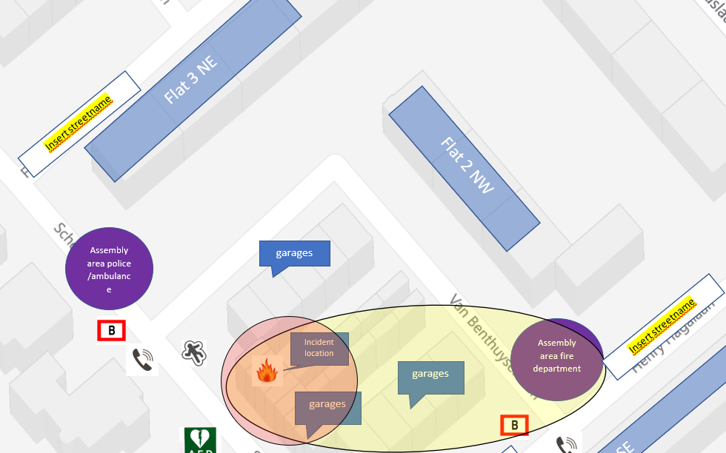

Figure A6.1: Overview map of an incident

The discussions after the various steps in the TTX are the most important aspect of the approach. This is typically the phase where learning is achieved by the participants. The trainer (and support trainers) is a key factor during this phase. Based on the learning objectives of the exercise it is up to him/her to guide this evaluation in a way that the participants are stimulated to reflect and contribute to the evaluation. The trainer can make use of the questions provided in Table 1, if needed.

During evaluation it is most valuable to let the participants first respond to their experiences and own behaviour throughout the exercise. After their reflection it is possible that the expert-observers/ domain specialists respond to the exercise behaviour. They reflect on the way participants acted and met the learning objectives. Then, the trainer fills in key elements that are not discussed during the evaluation phase. This includes both learning objective related elements and process related elements. The aim is to provide some take home elements, or to take some to the possible other exercise elements in the training course.

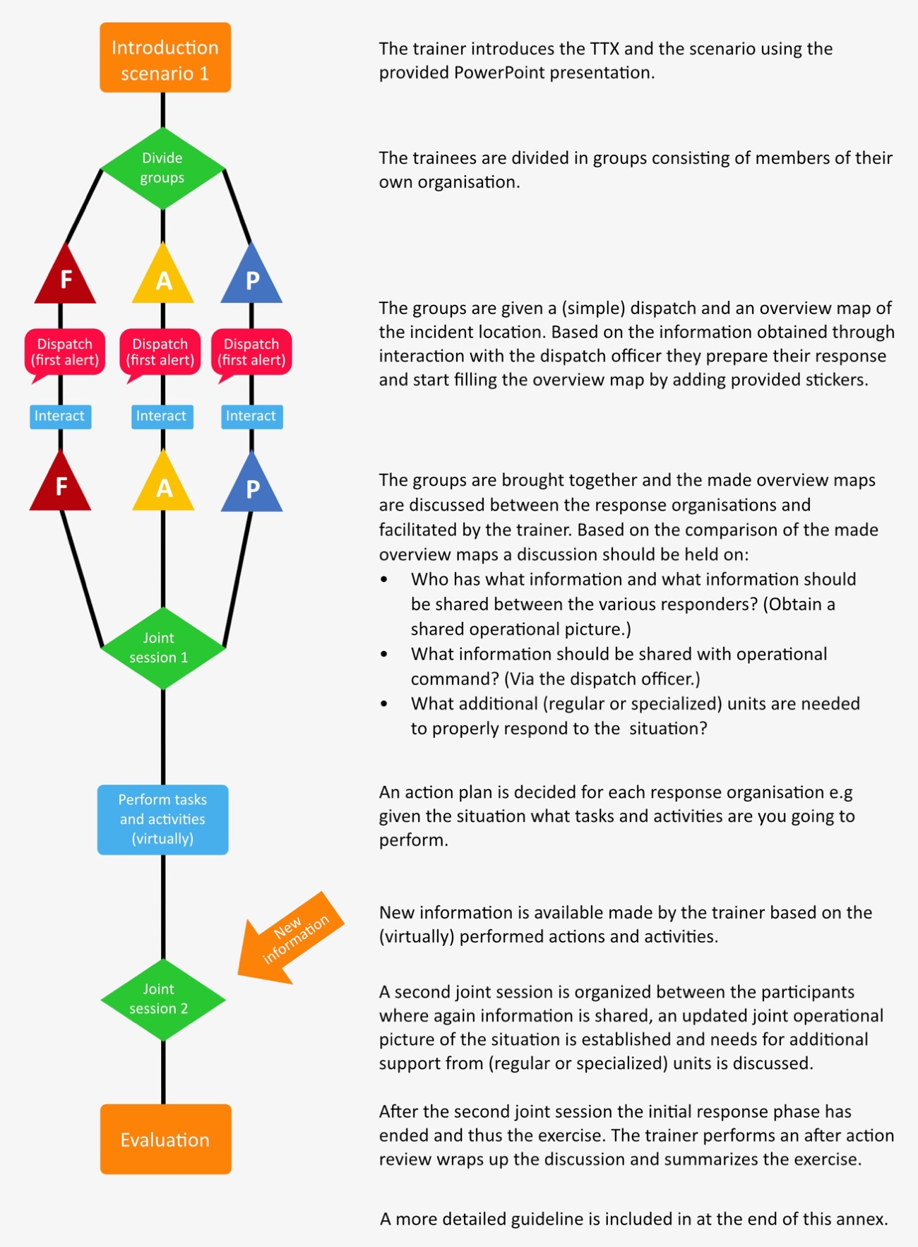The general flow of the TTX is the following (see Figure A6.2):

The trainer introduces the TTX and the scenario using the provided PowerPoint presentation.

The trainees are divided in groups consisting of members of their own organisation.

The groups are given a (simple) dispatch and an overview map of the incident location. Based on the information obtained through interaction with the dispatch officer they prepare their response and start filling the overview map by adding provided stickers.

The groups are brought together and the made overview maps are discussed between the response organisations and facilitated by the trainer. Based on the comparison of the made overview maps a discussion should be held on:

• Who has what information and what information should be shared between the various responders? (Obtain a shared operational picture.)

• What information should be shared with operational command? (Via the dispatch officer.)

• What additional (regular or specialized) units are needed to properly respond to the situation?

An action plan is decided for each response organisation e.g given the situation what tasks and activities are you going to perform.

New information is available made by the trainer based on the (virtually) performed actions and activities.

A second joint session is organized between the participants where again information is shared, an updated joint operational picture of the situation is established and needs for additional support from (regular or specialized) units is discussed.

After the second joint session the initial response phase has ended and thus the exercise. The trainer performs an after-action review wraps up the discussion and summarizes the exercise.

Figure A6.2: General flow of the TTX

**Duration of the exercise**: The TTX will take approximately 1 hour and 30 minutes (excluding breaks) for one incident. If both incidents are to be trained, then the total time is approximately 2 hours and 45 minutes.

## Exercise materials

The following materials are available to the trainer to run the TTX:

* MELODY guide for trainers (this document)
* PowerPoint presentation to provide guidance to the participants

In addition, for each of the two scenarios:

* A complete description of the incident and filled in overview map for use by the trainer and support trainers
* A detailed guideline for the trainers describing the various steps and trainer activities in a single table.
* A script describing the various steps of the TTX to the trainer
* Overview map of the incident
* Stickers that can be added to the overview maps in three sizes (A1, A2, A3)
* The dispatch information provided to the trainees by the support trainers
* Additional information in the form of pictures of the incident that can be provided to the trainees once they arrived on scene or performed certain actions
* Additional resources containing memory aids (METHANE, en route risk assessment questions) that can be provided to the trainers, if needed.
* Evaluation forms that can be used to track activities and can be used during the evaluation

The same documents listed in *italics* above are available for Scenario 1 (incident in the municipality building) as well in the respective subfolder on the MELODY website ([www.melodytraining.eu](http://www.melodytraining.eu)).

The documents needed to run the TTX can be downloaded from the members login web page on the MELODY website ([www.melodytraining.eu](http://www.melodytraining.eu)), WP5\Module 7 Interagency collaboration.

## Personnel:

### Trainer

Effective facilitation is critical to keeping participants focused on exercise objective(s). The trainer may ask about the decisions made, including how a decision was reached or what implications a decision might have. In case the discussion between the participants isn’t triggered enough by the scenario, or when it heads a different way than intended by the learning objectives, it is the task of the trainer to intervene, add or reflect on the process.

**The TTX ends** either when all actions have been discussed, participants fully understand the learning objective, or when the time limit is reached.

Bear in mind that, although the trainer may have more experience and knowledge, participants will likely learn more if coached through their decision-making process than if they are told what they should have done. In table 5, some questions are provided that might help to organize a meaningful after-action review. Not all questions are needed; when the discussion goes smoothly, only use the ones that guide discussion and focus on the learning objective.

The trainer performs four roles in the execution of the TTX:

1. **Elaborating on general process TTX**

First, the trainer will lead the TTX by

1. welcoming the participants,
2. explaining the objectives of the exercise,
3. explaining the program of the TTX,
4. explaining what is expected during the interaction, after action and evaluation moments.

The trainer runs the exercise and will be the first contact for the participants in case of questions.

1. **Guiding the TTX process**

Second, the trainer will guide the exercise by presenting information. In this role the trainer is supported by the support trainers. The support trainers will organize the counterplay and inserts in the scenario exercises where they will function as dispatch officer and provide information to the participants and receive request for additional (specialist) units in the role of remote command and control of the simulated incident. Each participating first responder service will be provided its dedicated support trainer. In case that dispatch officers are present during the TTX they could also play the role of participant during the TTX. In that case, the support trainer will provide inserts like a call from the incident scene, where dispatch offers must elaborate on the message (CBRN related questions).

1. **Observe/ coach the TTX**

Third, the trainer will observe and coach during the exercise. In this role, the trainer will observe group processes and discussions. As the exercise unfolds, the trainer may need to step in and help the team members clarify their decision making, by asking questions about their thought process and the factors they considered in making choices. For example, if they placed a high priority on helping a victim, or if they decided to enter a building that was clearly too dangerous, work through their decision-making process so they realize the potential negative results of their decision.

The trainer may want to take notes on discussions about tasks and interagency collaboration, decisions made, and actions taken so the trainer can refer to them later. Use the Events and Evaluation Form for Trainer(s) and Evaluator(s) to record notes.

1. **Prepare and conduct after action review**

Fourth, the trainer will conduct the after-action review after a TTX. The aim is to reinforce learning by helping participants evaluate their own decision making and interagency collaboration and their interaction and lessons learned to improve this interaction and collaboration in the future. It is a balance between:

* Asking participants why they made the choices they did and what they learned.
* Asking participants how they perceived their interaction and collaboration during the exercise, and which wishes and thoughts they have on how to improve this.
* Asking participants if they clearly knew what tasks and responsibilities other respond organizations had.
* Providing additional information and coaching.

In the after-action review the trainer can use the discussion questions listed in table A6.1.

Table A6.1: Suggested questions during discussions with participants

|  |  |
| --- | --- |
| MELODY topic | Suggested discussion question |
| First alert | * What was going on? * Was it clear what was going on? |
| Interaction with dispatch centre | * How was the interaction with the dispatch officer? * What specific CBRN related information did you ask? |
| Situational awareness | * How did the en-route risk assessment go? * On site, did you use METHANE? Why? * What did it mean for your role/tasks? * Which first responder organizations are necessary at the incident scene? |
| Information sharing | * What information was shared? * Did you miss some information necessary for your task execution? * What was a good option to ask/ get the necessary information? |
| Interagency collaboration | * Could you elaborate on the CBRN tasks you and the other first response organization were responsible for? * Was it discussed who was doing what at the incident scene? * When you are aware of this, what does this mean for your interagency collaboration? * What do you need from other first responder organizations? * Which secondary responder organizations/ capabilities are necessary at the incident scene? |
| Scale up response | * Did you discuss what other first responder organizations are necessary at the incident scene? * Which secondary responder organizations/ capabilities are necessary at the incident scene? |
| Lessons learned | * What is important to learn from this exercise? * What do you want to improve the next time? * What is your take home lesson? |
| If needed, then focus also on the incident itself:  Area set up | * Incident location * Hazard zones * Containment of hazard zones * Decontamination * Medical treatment |
| Decisions | * Decisions to mitigate the CBRN incident |

### 2. Support trainers

During the initial phase of the exercise the participants are active in small groups consisting of members of their own response organisations. The support trainers assist the trainer by acting as dispatch officer providing the relevant information to the participants and adding information to the overview maps of the CBRN incident.

### 3. Expert-Observers

In the context of the MELODY project, it is expected that observers will also be present during the exercise. The observers don’t have a formal role during the exercise but are present to assess the added value of the exercise and its future potential for their respective organisation. If agreed beforehand, observers could also be asked to reflect on the team performance during the TTX. Here, the focus is on assessing the learning objective.

It should be encouraged to add additional observers to the TTX. The trainers could then focus more on guiding the exercise while the observer(s) can focus on studying the participants’ behaviour, interaction and decisions made during the exercise.

The primary responsibility of the Observers is to assess the performance of the team based on the learning objectives. Events and expected actions listed on the *Events and Evaluation Form for Trainer(s) and Evaluator(s)* will help his/her observation process, since these are linked to the learning objectives.

Annex 7: Examples of composing a training

## Case 1: CBRN basics course for medical professions (4 hours)

You organize a training for ambulance personnel, general practitioners, and emergency medical services with no prior CBRN knowledge. You have 4 hours to conduct the training and have the availability of a training facility with separate rooms that are digitally equipped.

Stepwise guidance:

*Whom do you want to train? How much prior CBRN knowledge can you expect from these trainees?*Ambulance personnel, general practitioners, and emergency medical services with no prior CBRN knowledge

*Select relevant learning objectives for the target audience, based on the indicated target audience per learning objective as displayed in annex 2.*

|  |  |
| --- | --- |
| **#** | **Learning objective** |
| 1.1 | To recognize CBRN terminology (to be able to speak a common language) |
| 2.1 | To recognize the different groups of agents, their features and effects and list some relevant examples of incidents |
| 2.2 | To recognize a possible release and to summarize the different routes of dispersion |
| 2.3 | To recognize potential sources of CBRN agents, signs of dangerous goods, and improvised production facilities |
| 2.4 | To recall safe arrival procedures and basic safety in the field |
| 3.1 | To describe historical, ethical, sociological and scientific aspects of CBRN |
| 4.1 | To recognize signs of a potential CBRN release and (initiate first) respond(ers) |
| 5.1 | To recognize how to carry out an on-site risk assessment, zoning of the area, and isolation and registration of victims |
| 5.2 | To recognize how to carry out your work without forensic disruption of the scene |
| 5.3 | To recall some different DIM techniques |
| 5.4 | To recognize some different types of PPE and to recognize how to carry out some basic techniques |
| 5.5 | To recognize how to carry out basic decontamination procedures for people and domestic animals |
| 5.6 | To recognize how to apply appropriate medical care towards patients involved in a CBRN incident |
| 6.3 | To familiarize with and carry out triage and provide medical care in relation to CBRN scenario's |
| 7.1 | To reflect on the tasks, responsibilities and capabilities of other agencies and initiate interagency collaboration |

On what topics do you want to focus?  
A focus on CBRN basics and medical countermeasures

Adjust your previous selection by removing learning objectives that are not relevant for the aim of the training.

|  |  |
| --- | --- |
| **#** | **Learning objective** |
| 1.1 | To recognize CBRN terminology (to be able to speak a common language) |
| 2.1 | To recognize the different groups of agents, their features and effects and list some relevant examples of incidents |
| 2.2 | To recognize a possible release and to summarize the different routes of dispersion |
| 5.2 | To recognize how to carry out your work without forensic disruption of the scene |
| 5.6 | To recognize how to apply appropriate medical care towards patients involved in a CBRN incident |
| 6.3 | To familiarize with and carry out triage and provide medical care in relation to CBRN scenario's |

Note that only learning objectives that are relevant for all three target groups are selected

How much time have you got for your course? What resources in form of trainer colleagues, indoor/outdoor facilities, digital solutions do you have available?

There are 4 hours available for training*.* There is one trainer and a training facility with separate rooms that are digitally equipped available.

Adjust your previous selection by removing learning objectives if needed and deciding how to deliver the training. Extend time spent on specific learning objectives by increasing for example the number of scenario discussions or time for reflective test questions and group work. Decide if you want different trainers for different parts, scenario discussions in classroom setting or in mock-up environment, with certain parts in a digital online format, etc. Maybe your organisation uses an online learning platform. In that case you might want to set up the MELODY e-learning in a manner that allows you to interact with and to supervise your trainees while they are learning. You could also transfer MELODY classroom lectures into webinars and integrate these in your learning platform.

CBRN basics (1.1, 2.1, and 2.2):

E-learning prior to the on-site training 80 min

Medical treatment and triage:

Classroom presentations 6.3.1 and 6.3.2 100 min

Scenario discussion (e.g. scenario 11 and 21) for 5.6.P and 6.3.P 60 min

|  |  |  |  |  |
| --- | --- | --- | --- | --- |
| **Number** |  | **Presentations** | Time (min) |  |
| 1.1 | 1.1 | What is CBRN (definitions; accidents v. attacks; C v. B v. RN) | 15 | **Available as e-learning** |
| 2.1 | 2.1.1 | Classification, properties, dispersion (including explosives), signs and triggers, etc. | 25 |
| 2.1.2 | Some relevant examples of incidents | 10 |
| *2.1 Test* | *Test Questions* | *10* |
| 2.2 | 2.2.1 | Routes of exposure, symptoms, etc. | 25 |
| 2.2.2 | Dispersion of CBRN agents | 20 |
| *2.2 Test* | *Test Questions* | 10 |
| *5.2* | *5.2* | *Forensic awareness* | *40* |  |
| *5.2 Test* | *Test questions* | *10* |  |
| *5.2 P* | *Scenario discussions: Forensic awareness* | *15/Scenario* |  |
| 5.6 | *5.6* | *Treatment methods of patients involved in a CBRN incident* | *30* |  |
| *5.6 Test* | *Test questions* | *10* |  |
| 5.6 P | Scenario discussions: Treatment methods of patients involved in a CBRN incident | 15/Scenario |  |
| 6.3 | 6.3.1 | Triage related to CBRN | 40 |  |
| 6.3.2 | Medical treatments, countermeasures and protection (see also 5.3) | 60 |  |
| *6.3 Test* | *Test questions* | *30* |  |
| 6.3 P | Scenario discussions: Triage and medical treatment related to CBRN | 15/scenario |  |

*Depicted in black font are the selected topics. In red italic font are the presentations that have been removed due to limited time or non-preferred training method.*

Note that:

Due to limited time 5.2 “Forensic Awareness” is left out of the training program, as the focus on CBRN basics and medical countermeasures

Classroom presentation 5.6 “Treatment methods of patients involved in a CBRN incident” is left out of the training program, as classroom presentations 6.3.1 and 6.3.2 cover the same topic, but are more in depth.

The test questions are left out of the training as there are questions in the e-learning and scenario discussions to put theory into practice.

*What adaptations to the national situation and which examples will be needed to align the content of the training to the national situation?*

*Decide on interesting (recent) examples reflecting situations that are likely to be faced by the trainees in their daily job, and replace MELODY procedures for national procedures in case these diverse.*

As 1.1, 2.1 and 2.2 are provided as e-learning, no national adaptations can be made.

Classroom presentations 6.3.1 and 6.3.2 need to be checked by the trainer if the procedures described in the MELODY training material align with national procedures and where needed to be adapted.

National examples can be included in classroom presentations 6.3.1 and 6.3.2 and scenario discussions 5.6 and 6.3 if relevant examples exist.

## Case 2: CBRN refresher course for dispatch officers, police and ambulance personnel (1 day)

You organize a refresher training for dispatch officers, police and ambulance personnel, who already have some basic knowledge of CBRN. You have 1 day to conduct the training and have the availability of a training facility with 3 separate rooms.

Stepwise guidance:

*Whom do you want to train? How much prior CBRN knowledge can you expect from these trainees?*Dispatch officers, police and ambulance personnel, who already have some basic knowledge of CBRN

*Select relevant learning objectives for the target audience, based on the indicated target audience per learning objective as displayed in annex 2.*

|  |  |
| --- | --- |
| **#** | **Learning objective** |
| 3.1 | To describe historical, ethical, sociological and scientific aspects of CBRN |
| 4.1 | To recognize signs of a potential CBRN release and (initiate first) respond(ers) |
| 5.1 | To recognize how to carry out an on-site risk assessment, zoning of the area, and isolation and registration of victims |
| 5.2 | To recognize how to carry out your work without forensic disruption of the scene |
| 5.3 | To recall some different DIM techniques |
| 5.4 | To recognize some different types of PPE and to recognize how to carry out some basic techniques |
| 5.5 | To recognize how to carry out basic decontamination procedures for people and domestic animals |
| 5.6 | To recognize how to apply appropriate medical care towards patients involved in a CBRN incident |
| 6.1 | To differentiate a possible CBRN incident (from normal incident) and to carry out appropriate procedures & protocols |
| 6.3 | To familiarize with and carry out triage and provide medical care in relation to CBRN scenario's |
| 7.1 | To reflect on the tasks, responsibilities and capabilities of other agencies and initiate interagency collaboration |

*On what topics do you want to focus?*

*Adjust your previous selection by removing learning objectives that are not relevant for the aim of the training.*

Option 1:  
Focus on recognizing signs of a potential CBRN release and interagency collaboration. For police and ambulance services carrying out on-site risk assessment and carrying out work without forensic disruption of the scene. For dispatch officers a special focus on how to initiate an alarm protocol and CBRN extras.

|  |  |
| --- | --- |
| **#** | **Learning objective** |
| 3.1 | To describe historical, ethical, sociological and scientific aspects of CBRN |
| 4.1 | To recognize signs of a potential CBRN release and (initiate first) respond(ers) |
| 5.1 | To recognize how to carry out an on-site risk assessment, zoning of the area, and isolation and registration of victims |
| 5.2 | To recognize how to carry out your work without forensic disruption of the scene |
| 6.1 | To differentiate a possible CBRN incident (from normal incident) and to carry out appropriate procedures & protocols |
| 7.1 | To reflect on the tasks, responsibilities and capabilities of other agencies and initiate interagency collaboration |

Option 2:  
Focus on operational tasks, task specific response and interagency collaboration. Especially for police and dispatch officers it should be a practical day.

|  |  |
| --- | --- |
| **#** | **Learning objective** |
| 4.1 | To recognize signs of a potential CBRN release and (initiate first) respond(ers) |
| 5.1 | To recognize how to carry out an on-site risk assessment, zoning of the area, and isolation and registration of victims |
| 5.2 | To recognize how to carry out your work without forensic disruption of the scene |
| 5.3 | To recall some different DIM techniques |
| 5.4 | To recognize some different types of PPE and to recognize how to carry out some basic techniques |
| 5.5 | To recognize how to carry out basic decontamination procedures for people and domestic animals |
| 5.6 | To recognize how to apply appropriate medical care towards patients involved in a CBRN incident |
| 6.1 | To differentiate a possible CBRN incident (from normal incident) and to carry out appropriate procedures & protocols |
| 6.3 | To familiarize with and carry out triage and provide medical care in relation to CBRN scenario's |
| 7.1 | To reflect on the tasks, responsibilities and capabilities of other agencies and initiate interagency collaboration |

*How much time have you got for your course? What resources in form of trainer colleagues, indoor/outdoor facilities, digital solutions do you have available?*

There is 1 day available for training*.* There are three trainers available and a training facility with 3 separate rooms that are digitally equipped.

*Adjust your previous selection by removing learning objectives if needed and deciding how to deliver the training. Extend time spent on specific learning objectives by increasing for example the number of scenario discussions or time for reflective test questions and group work. Decide if you want different trainers for different parts, scenario discussions in classroom setting or in mock-up environment, with certain parts in a digital online format, etc. Maybe your organisation uses an online learning platform. In that case you might want to set up the MELODY e-learning in a manner that allows you to interact with and to supervise your trainees while they are learning. You could also transfer MELODY classroom lectures into webinars and integrate these in your learning platform.*

Option 1:

Plenary session for dispatch officers, police and ambulance personnel (115 min)

Revision of CBRN basic knowledge by plenary discussion of test questions   
2.1.Test, 2.2.Test, 2.3.Test and 2.4.Test 45 min

Classroom presentation 4.1 ‘First alert’ 40 min

2 scenario discussions for 4.1.P First alert (e.g. scenario 17 and 21) 30 min

Parallel sessions

Dispatch officers (155 min):

Classroom Presentation 3.1.1 Elaborated history 45 min

Classroom Presentation 3.1.3 Advanced information on CBRN 50 min

Classroom Presentation 6.1 ‘initiate alarm protocol’ 30 min

2 scenario discussions for 6.1 (e.g. scenario 6 and 21) 30 min

Police and ambulance services (160 min):

Classroom Presentation 5.1.1, 5.1.2, 5.1.3 90 min

Classroom Presentation 5.2 40 min

Scenario discussions using scenario 21 for 5.1 and 5.2 30 min

Plenary session for dispatch officers, police and ambulance personnel (210 min)

Classroom presentation 7.1 ‘Interagency collaboration’ 60 min

Table Top Exercise 7.1 P ‘Interagency collaboration’ (scenario 17) 150 min

|  |  |  |  |
| --- | --- | --- | --- |
| **Number** |  | **Presentations** | Time (min) |
| 2.1 | 2.1 Test | Test Questions | 10 |
| 2.2 | 2.2 Test | Test Questions | 10 |
| 2.3 | 2.3 Test | Test Questions | 10 |
| 2.4 | 2.4 Test | Test Questions | 15 |
| 3.1 | 3.1.1 | Elaborated history: development of agents, actual incidents the past & context | 45 |
| *3.1.2* | *Social, psychological & ethical issues (e.g. moral issues, rescue victims versus own risks, isolation/separation of possible contaminated people, child-parent separation, aftercare)* | *25* |
| 3.1.3 | Advanced information on C, B, R and N agents | 50 |
| *3.1 Test* | *Test questions* | *20* |
| 4.1 | 4.1 | Identify possible CBRN releases by asking the right questions to the person who makes the call, including issues such as meteorology, wind, symptoms, and knowing which information to share with chain of command (escalation protocol). | 40 |
| 4.1 P | Scenario discussions: Identify possible CBRN releases by asking the right questions | 15/scenario |
| 5.1 | 5.1.1 | Preparations for on-site arrival, en-route (upwind) approach, incident analysis. On-site risk/threat assessment. | 35 |
| 5.1.2 | Security of the area, upwind approach (including traffic control), hot zone, warm zone, cold zone | 40 |
| 5.1.3 | Isolate people and domestic animals on scene | 15 |
| *5.1.4* | *Registration of victims* | *25* |
| *5.1 Test* | *Test questions* | *15* |
| 5.1 P | Scenario discussions: Arrival on-site: security, isolation and registration of victims and | 15/Scenario |
| 5.2 | 5.2 | Forensic awareness | 40 |
| *5.2 Test* | *Test questions* | *10* |
| 5.2 P | Scenario discussions: Forensic awareness | 15/Scenario |
| 6.1 | 6.1 | How to recognize possible CBRN release and initiate alarm protocol [COUNTRY BASED] | 30 |
| *6.1 Test* | *Test questions* | *5* |
| 6.1 P | Scenario discussions: How to recognize possible CBRN release and initiate alarm protocol [COUNTRY BASED] | 15/scenario |
| 7.1 | 7.1 | Elaborate on tasks of other responders at CBRN scene, and their value. | 60 |
| 7.1 P | Table top exercise on interagency collaboration | 150 |

*Depicted in black font are the selected presentations. In red italic font are the presentations that are removed due to limited time or preferred training method.*

Note that:

Due to limited time classroom presentation 3.1.2 “Social, psychological & ethical issues” is left out of the CBRN extra training for dispatch officers, as it has the least relevance for this target group.

Classroom presentation 5.1.4 “Registration of victims” is left out of the training program due to limited time.

The test questions for modules 3, 5, and 6 are left out of the training as the scenario discussions are included to put theory into practice.

Option 2:

Prior to the training (45 min):

Participants are requested to complete test questions 2.1.Test, 2.2.Test,   
2.3.Test and 2.4.Test to assess the basic knowledge 45 min

Plenary session for dispatch officers, police and ambulance personnel (50 min):

Short explanation of basic concepts that were often unknown based   
on the test questions 20 min

2 scenario discussions for 4.1.P First alert (e.g. scenario 18 and 22) 30 min

Parallel sessions

Dispatch officers (145 min):

Classroom Presentation 6.1 ‘initiate alarm protocol’ 30 min

Mock-up of 3 scenario’s for 6.1 (e.g. scenario 4, 8 and 18) 90 min

Time for discussion and reflective questions 25 min

Police and Ambulance services (30 min):

Scenario discussions using scenario 22 for 5.1 and 5.2 30 min

Police (130 min):

Classroom Presentation 5.4 ‘PPE’ 20 min

Hands-on training 5.4 ‘PPE’ 45 min

Mock up scenario discussions using scenario 19 for 4.1, 5.1 and 5.2 65 min

Ambulance services (130 min):

Classroom Presentation 6.3.1 ‘Triage’ 40 min

Classroom Presentation 6.3.2 ‘Medical treatment’ 60 min

Scenario discussions using scenario 22 for 5.3 and 6.3 30 min

Plenary session for dispatch officers, police and ambulance personnel (240 min)

Classroom presentation 7.1 ‘Interagency collaboration’ 60 min

Mock-up TTX 7.1 P ‘Interagency collaboration’ (scenario 18) 180 min

|  |  |  |  |
| --- | --- | --- | --- |
| **Number** |  | **Presentations** | Time (min) |
| 2.1 | 2.1 Test | Test Questions | 10 |
| 2.2 | 2.2 Test | Test Questions | 10 |
| 2.3 | 2.3 Test | Test Questions | 10 |
| 2.4 | 2.4 Test | Test Questions | 15 |
| 4.1 | *4.1* | *Identify possible CBRN releases by asking the right questions to the person who makes the call, including issues such as meteorology, wind, symptoms, and knowing which information to share with chain of command (escalation protocol).* | *40* |
| 4.1 P | Scenario discussions: Identify possible CBRN releases by asking the right questions | 15/scenario |
| 5.1 | *5.1.1* | *Preparations for on-site arrival, en-route (upwind) approach, incident analysis. On-site risk/threat assessment.* | *35* |
| *5.1.2* | *Security of the area, upwind approach (including traffic control), hot zone, warm zone, cold zone* | *40* |
| *5.1.3* | *Isolate people and domestic animals on scene* | *15* |
| *5.1.4* | *Registration of victims* | *25* |
| *5.1 Test* | *Test questions* | *15* |
| 5.1 P | Scenario discussions: Arrival on-site: security, isolation and registration of victims and | 15/Scenario |
| 5.2 | *5.2* | *Forensic awareness* | *40* |
| *5.2 Test* | *Test questions* | *10* |
| 5.2 P | Scenario discussions: Forensic awareness | 15/Scenario |
| 5.3 | *5.3* | *Detection, Identification and Monitoring (DIM)* | *15* |
| *5.3 Test* | *Test questions* | *10* |
| 5.4 | 5.4 | Personal protective equipment (PPE) | 20 |
| *5.4 Test* | *Test questions* | *10* |
| 5.4 P | Hands-on training: Personal protective equipment (PPE) | 45 |
| 5.5 | *5.5* | *Decontamination (of people and domestic animals)* | *20* |
| *5.5 Test* | *Test questions* | *10* |
| *5.5 P* | *Hands-on training: Decontamination (of people and domestic animals)* | *90* |
| 5.6 | *5.6* | *Treatment methods of patients involved in a CBRN incident* | 30 |
| *5.6 Test* | *Test questions* | *10* |
| 5.6 P | Scenario discussions: Treatment methods of patients involved in a CBRN incident | 15/Scenario |
| 6.1 | 6.1 | How to recognize possible CBRN release and initiate alarm protocol [COUNTRY BASED] | 30 |
| *6.1 Test* | *Test questions* | *5* |
| 6.1 P | Scenario discussions: How to recognize possible CBRN release and initiate alarm protocol [COUNTRY BASED] | 15/scenario |
| 6.3 | 6.3.1 | Triage related to CBRN | 40 |
| 6.3.2 | Medical treatments, countermeasures and protection (see also 5.3) | 60 |
| *6.3 Test* | *Test questions* | *30* |
| 6.3 P | Scenario discussions: Triage and medical treatment related to CBRN | 15/scenario |
| 7.1 | 7.1 | Elaborate on tasks of other responders at CBRN scene, and their value. | 60 |
| 7.1 P | Table top exercise on interagency collaboration | 150 |

*Depicted in black font are the selected presentations. In red italic font are the presentations that are removed due to limited time or preferred training method.*

Note that:

Because it is a refresher course that needs to be interactive, classroom presentations are largely left out of the training program and there is a focus on scenario discussions and practical work.

Dispatch officers and ambulance services focus on task-specific presentations and scenario discussions, respectively 6.1 and 6.3

Police focuses on operational aspects (module 5) with a practical focus.

The test questions for modules 3, 5, and 6 are left out of the training as the scenario discussions are included to put theory into practice.

*What adaptations to the national situation and which examples will be needed to align the content of the training to the national situation?*

*Decide on interesting (recent) examples reflecting situations that are likely to be faced by the trainees in their daily job, and replace MELODY procedures for national procedures in case these diverse.*

Classroom presentations 6.1, 6.3.1 and 6.3.2 need to be checked by the trainer if the procedures described in the MELODY training material align with national procedures and where needed to be adapted.

National examples can be included in classroom presentations and scenario discussions if relevant examples exist.

For hands-on practical training 5.4 on PPE the national available PPE in police cars can be used.

1. A European CBRN Training Curriculum for first responders. Stöven et al., 2016; [www.melodytraining.eu](http://www.melodytraining.eu)
2. https://www.bloomstaxonomy.net/
3. https://www.bloomstaxonomy.net/
4. https://ec.europa.eu/home-affairs/sites/homeaffairs/files/what-we-do/policies/european-agenda-security/20171018_action_plan_to_enhance_preparedness_against_chemical_biological_radiological_and_nuclear_security_risks_en.pdf